**John Alingwa**

Germantown, MD

Tel: +1 (920) 308-1758

Email: xchaleur@gmail.com

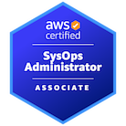    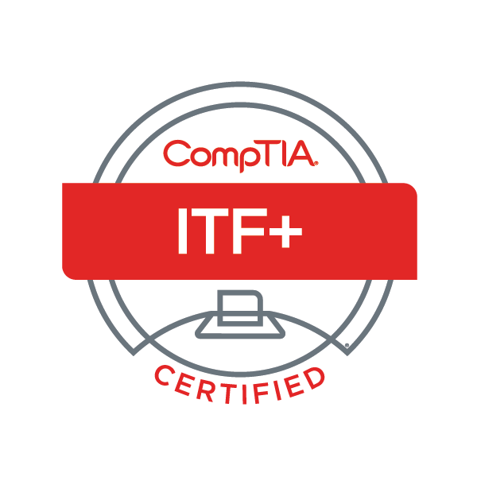

**Summary of Qualifications:**

A self-motivated systems administrator with 6 years of experience in both on-premises and AWS environments. Passionate about learning new technologies and tackling challenges, I am committed to growing in this field for the next 10+ years. The constant evolution of technology excites me, and I thrive on the opportunity to continually expand my knowledge.

**Technical Skills and Technology Stack:**  
**- Cloud Orchestration/Automation:** AWS CloudFormation, AWS Systems Manager, Terraform, Puppet, SCCM.

**- Security:** AWS Security Hub, AWS GuardDuty, AWS Shield, AWS Firewall Manager, AWS Inspector.

**- Monitoring & Event Management:** AWS CloudWatch (Events & Logs), AWS SNS, AWS S3, NGT (Nutanix Guest Tools), Site24x7, AirLock, TeamDynamix, Service Desk, OpsGenie.

**- Identity & Access Management:** AWS Organizations, AWS IAM, AWS AD Connector, Active Directory, AWS Workspaces, AWS Secrets Manager, CyberArk.

**- Governance & Compliance:** ADUC, Intune, AWS Config Rules, AWS Organizations, AWS Control Tower, AWS Trusted Advisor, AWS Budgets, AWS License Manager.

**- Programming Languages / Scripting:** PowerShell, Bash, JSON, YAML, Python, HTML, CSS.

**- Application Delivery:** GitHub, Confluence, Jenkins, AWS CodePipeline, AWS CodeCommit, GitLab.

**- Data Protection:** AWS Certificate Manager, AWS KMS, Snapshot Lifecycle Manager, Rubrik.

**- Network:** VPC, VGW, TGW, CGW, IGW, NGW, DNS, DHCP, Switches.

**- Image & Patch Management:** AWS SSM Patch Manager, SCCM, Intune, WSUS.

**- AWS Platform:** AWS CloudFormation, AWS Lambda, AWS Systems Manager, S3, VPC, EC2, ELB, RDS, SNS, SQS, SES, Route 53, CloudFront, AWS Auto Scaling, Trusted Advisor, CloudWatch.

**Professional Experience:**

**System Administrator**  
**Leonardo DRS – RADA , Germantown, MD                                     06/2022 – 08/2024**

* Implemented, and managed the company's Active Directory (AD) domain controller from the ground up, ensuring secure authentication, streamlined access control, and efficient management of user accounts and resources across the organization.
* Administered and optimized network switch configurations, ensuring efficient traffic management and redundancy. Spearheaded the setup and configuration of the company's datacenter, delivering robust, scalable infrastructure to support mission-critical applications.
* Configured and managed Jira servers, ensuring optimal performance, reliability, and seamless integration with organizational workflows.
* Created and deployed the base ISO image for Windows endpoint laptops and VMs across the organization, ensuring consistent configuration, security standards, and streamlined deployment processes.
* Implemented thorough testing protocols for third-party software packages and dependencies on Linux servers, ensuring system stability, compatibility, and security during deployment.
* Successfully recovered corrupted and deleted servers using **Nutanix Snapshots** and **Rubrik**, ensuring minimal downtime and preserving critical data integrity
* Monitored and managed unapproved software installations on user computers using **Airlock**, ensuring compliance with security policies and mitigating potential risks.
* Managed Active Directory (AD) user and computer policies in alignment with Zero Trust security principles, enforcing strict access controls and minimizing security risks across the organization.
* Managed and maintained software running on Docker containers, optimizing containerized applications for performance and reliability across the organization’s infrastructure.
* Developed PowerShell scripts to automate tasks such as VM decommissioning, Active Directory account creation, and other routine processes, significantly improving efficiency and reducing manual effort.
* Developed Bash scripts to automate software updates, network configurations, and routine tasks on Linux servers, enhancing system efficiency and reducing manual intervention.
* Deployed SCCM application packages and company-wide software updates for endpoint users, ensuring timely distribution and maintaining system consistency across the organization.
* Managed the company’s file share system, creating centralized storage solutions for each department to facilitate seamless collaboration and secure file management.
* Set up Jenkins CI/CD pipelines on a Linux server for continuous integration, including managing directories and containers.
* Experimented with Linux Directory Hierarchy within a dedicated test lab environment for better system understanding and optimization.
* Implemented and managed cron jobs to rotate Apache log files, preventing them from growing too large and ensuring optimal server performance and disk space management.
* Upgraded NAS storage in the datacenter to increase capacity for the company’s file share, ensuring scalable storage solutions to meet growing data demands.
* Collaborated directly with endpoint users to troubleshoot a wide range of issues beyond IT, providing comprehensive support and ensuring smooth operational workflows.
* Configured endpoint user laptops using PXE boot, streamlining the deployment process and ensuring consistent system setups across the organization.
* Managed S/MIME and SSL certificates for secure email communication and website encryption, ensuring data integrity and compliance with security standards
* Resolved S/MIME certificate issues for endpoint users, ensuring secure email communication and seamless user experience.
* Managed license servers for both endpoint and IT software, ensuring proper license allocation, compliance, and uninterrupted access to essential tools across the organization.
* Leveraged Python to automate a variety of tasks, including server management and password vault operations, improving efficiency, security, and reducing manual workload.
* Utilized software like BeyondTrust to provide remote assistance to end users and manage endpoint devices, ensuring secure and efficient support across the organization.
* Used Zscaler to manage and monitor website access, enforcing web security policies and ensuring safe browsing for endpoint users across the organization.
* Utilized Secrets Manager to securely store and manage sensitive information such as API keys, passwords, and credentials, enhancing security and access control within the organization.
* Managed the DNS and DHCP servers, ensuring reliable network addressing and name resolution across the organization for seamless connectivity and performance.
* Collaborated with vendors to implement software solutions within the organization’s environment, ensuring seamless integration and alignment with business needs.
* Designed, configured, and maintained the RDS Broker and session pool, ensuring secure, efficient, and scalable remote desktop services for users across the organization.

**Infrastructure Engineer**  
**Dartmouth College, Dartmouth, NH.                                       08/2020 – 05/2022**

* **Trained employees** across multiple departments on network operations, including login procedures, network management software, permissions, troubleshooting printing issues, security protocols, and software usage.
* **Led and played a key role** in the **vCenter to Nutanix migration**, ensuring seamless transition and system continuity.
* **Ensured compliance** of server hardware, operating systems, software, and procedures with organizational standards and the strategic business plan.
* Installed and configured firewalls, anti-virus software, and deployed **two-factor authentication** to safeguard sensitive legal documentation.
* **Maintained 800+ Windows and Linux VMs**, managing configurations and system monitoring to optimize performance.
* Utilized **Site24/7** and **OpsGenie** to monitor VMs, promptly addressing performance issues.
* **Completed tasks via TeamDynamix**, collaborating with Network, Security, and client teams to resolve complex technical issues.
* **Configured and managed VMs** in **vSphere** and **Nutanix** environments, while also contributing to system backups and recovery.
* **Worked on AWS projects**, implementing and managing cloud solutions to enhance infrastructure.
* Configured **Pharos** for printing services across the organization, improving efficiency.
* Renewed **SSL certificates**, managed **Microsoft RDS session hosts**, and implemented solutions to prevent disk space issues.
* Enabled **RDP connections** on Windows servers and configured user accounts, permissions, and passwords.
* Conducted **system backups and data recovery** using **Rubrik** and **Nutanix Recovery Points**.
* Installed and configured network devices, including **routers, switches, and firewalls**.
* Experience with **CyberArk**, performing account reconciliation, password changes, and cybersecurity measures.
* **Generated Puppet certifications** on Linux servers and managed software deployment through **SCCM**.
* Increased disk size and modified IP/hostname on **RHEL 8 and 9 servers**, launching and managing VMs.
* Collaborated with the IT team to implement new hardware and software, resulting in a **25% improvement** in system usability and performance.

**AWS Engineer**

**JJtech, Bowie, MD.                                         05/2019 – 6/2020**

* Provisioned and automated AWS infrastructure using CloudFormation, ensuring scalable, secure environments.
* Developed and implemented detective guardrails using Cloud Custodian policies and AWS Config to enforce compliance and best practices.
* Implemented AWS security best practices, including multi-factor authentication, access key rotation, KMS encryption, security groups, NACLs, S3 bucket policies, ACLs, and DDoS mitigation.
* Designed and maintained CI/CD pipelines using Jenkins, GitHub, and Git, enabling efficient code build, testing, and deployment processes.
* Monitored end-to-end infrastructure performance using CloudWatch, SNS, and detailed log management to ensure optimal performance and quick issue resolution.
* Automated operational tasks across AWS resources using AWS Systems Manager, improving operational efficiency and consistency.
* Led the design and migration of AWS infrastructure projects, ensuring seamless application transition and optimal architecture.
* Integrated AWS Single Sign-On (SSO) with on-premise Active Directory (AD) for unified identity and access management.
* Developed and documented security guardrails for AWS environments, ensuring adherence to security standards and compliance.
* Optimized AWS resources by implementing cost-saving strategies such as reserved instances, S3 lifecycle policies, and Auto Scaling.
* Scheduled and managed EC2s
* Created Snapshot API calls for automated EBS volume snapshots, ensuring data backups and recovery.
* Configured CloudWatch alarms and detailed monitoring for operational and performance metrics, enabling real-time alerts and issue resolution.
* Provisioned and managed Kubernetes clusters, monitoring performance with Prometheus and Grafana.
* Configured infrastructure using CloudFormation (JSON/YAML) and Terraform; debugged and optimized Infrastructure as Code (IaC) deployments.
* Performed updates, patches, and troubleshooting for Linux and Windows servers, ensuring stable and secure server environments.
* Installed, upgraded, and maintained Linux applications, performing regular monitoring and troubleshooting.
* Conducted load balancer traffic redirection testing to optimize network routing and performance.
* Configured and tested multiple AMIs to evaluate application performance across different environments.
* Built and managed CI/CD pipelines for Kubernetes environments, streamlining testing and production workflows.
* Monitored runtime system performance, including CPU, bandwidth, disk space, and log files using New Relic.
* Effectively communicated cloud solutions to non-technical stakeholders and customers.
* Managed GitHub repositories for version control, including cloning, pushing from local, and repository maintenance.

**Education:**

## Montgomery College

### 2016 - Present, Takoma Park, MD

**Certifications:**

* CompTIA IT Fundamentals (ITF+) Certification 11/2023
* AWS Certified SysOps Administrator 12/2023